Experiment 10

Pranav Garg – 2401010034

AIM: Using the tables “DEPARTMENTS” and “EMPLOYEES” from Lab 9 perform the following queries:
  - Display the employee details, departments that the departments are same in both the emp and dept.
  - Display the employee name and Department name by implementing a left outer join.
  - Display the employee name and Department name by implementing a right outer join.
  - Display the details of those who draw the salary greater than the average salary.

Solution :
CREATE DATABASE IF NOT EXISTS company_joins; USE company_joins;
CREATE TABLE IF NOT EXISTS Departments ( DeptNo INT PRIMARY KEY,
DeptName VARCHAR(50), DeptLocation VARCHAR(50)
);
CREATE TABLE IF NOT EXISTS Employees ( EmpId INT PRIMARY KEY,
EmpName VARCHAR(50),
EmpSalary INT, DeptNo INT
);
INSERT INTO Departments (DeptNo, DeptName, DeptLocation) VALUES (10, 'mathematics', 'block a'),
(20, 'commerce', 'block b'),
(30, 'science', 'block c'),
(40, 'humanities', 'block d');
INSERT INTO Employees (EmpId, EmpName, EmpSalary, DeptNo) VALUES (701, 'amit kumar', 45000, 10),
(702, 'sunita devi', 55000, 20),
(703, 'rahul sharma', 38000, 10),
(704, 'priya nair', 60000, 30),
(705, 'vicky singh', 42000, NULL);

- Display the employee details, departments that the departments are same in both the emp and dept.
SELECT E.*, D.DeptName, D.DeptLocation FROM Employees E
JOIN Departments D ON E.DeptNo = D.DeptNo;
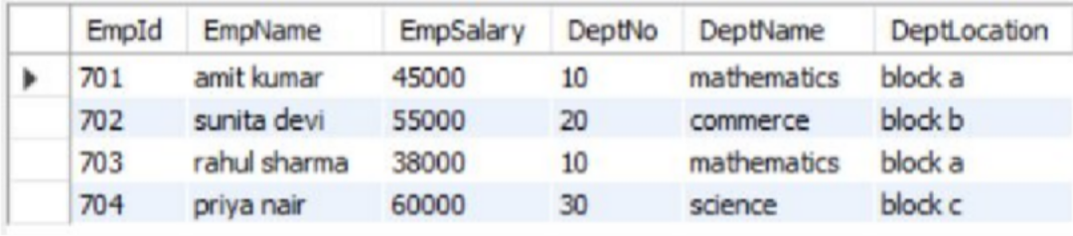

(b) Left Outer Join
SELECT e.emp_name, d.dept_name
FROM Employees e
LEFT JOIN Departments d
ON e.dept_no = d.dept_no;
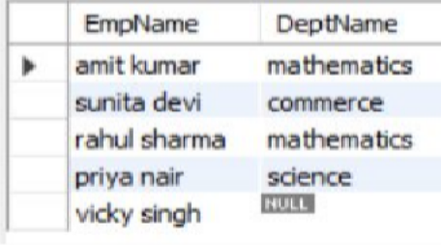

(c) Right Outer Join
SELECT e.emp_name, d.dept_name
FROM Employees e
RIGHT JOIN Departments d
ON e.dept_no = d.dept_no;
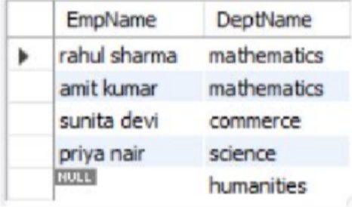

(d) Salary greater than average
SELECT *
FROM Employees
WHERE emp_salary > (SELECT AVG(emp_salary) FROM Employees);
